Lasting achievements in K–8 Jason Zimba

Most of the K–8 content standards trace explicit steps A → B → C in a progression. This can sometimes make it seem as if any given standard only exists for the sake of the next one in the progression. There are, however, culminating or capstone standards (I sometimes call them “pinnacles”), most of them in the middle grades, that remain important far beyond the particular grade level in which they appear. This is signaled in the Standards themselves (p. 84):

The evidence concerning college and career readiness shows clearly that the knowledge, skills, and practices important for readiness include a great deal of mathematics prior to the boundary defined by (+) symbols in these standards. Indeed, some of the highest priority content for college and career readiness comes from Grades 6–8. This body of material includes powerfully useful proficiencies such as applying ratio reasoning in real-world and mathematical problems, computing fluently with positive and negative fractions and decimals, and solving real-world and mathematical problems involving angle measure, area, surface area, and volume. Because important standards for college and career readiness are distributed across grades and courses, systems for evaluating college and career readiness should reach as far back in the standards as Grades 6–8. It is important to note as well that cut scores or other information generated by assessment systems for college and career readiness should be developed in collaboration with representatives from higher education and workforce development programs, and should be validated by subsequent performance of students in college and the workforce.

One example of a standard that refers to skills that remain important well beyond middle school is 7.EE.3:

Solve multi-step real-life and mathematical problems posed with positive and negative rational numbers in any form (whole numbers, fractions, and decimals), using tools strategically. Apply properties of operations to calculate with numbers in any form; convert between forms as appropriate; and assess the reasonableness of answers using mental computation and estimation strategies. For example: If a woman making $25 an hour gets a 10% raise, she will make an additional 1/10 of her salary an hour, or $2.50, for a new salary of $27.50. If you want to place a towel bar 9 3/4 inches long in the center of a door that is 27 1/2 inches wide, you will need to place the bar about 9 inches from each edge; this estimate can be used as a check on the exact computation.

Other lasting achievements from K–8 would include working with proportional relationships and unit rates (6.RP.3; 7.RP.1,2); working with percentages (6.RP.3e; 7.RP.3); and working with area, surface area, and volume (7.G.4,6).
As indicated in the quotation from the Standards, skills like these are crucial tools for college, work and life. They are not meant to gather dust during high school, but are meant to be applied in increasingly flexible ways, for example to meet the high school standards for Modeling. The illustration below shows how these skills fit in with both the learning progressions in the K–8 standards as well as the demands of the high school standards and readiness for careers and a wide range of college majors.

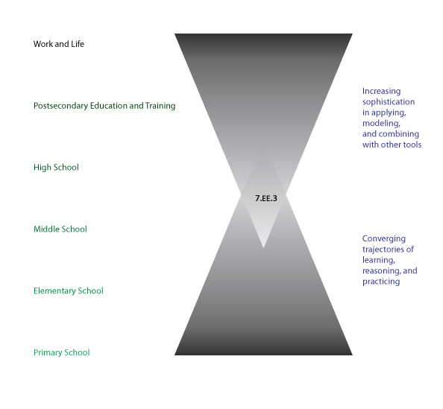

As shown in the figure, standards like 7.EE.3 are best thought of as descriptions of component skills that will be applied flexibly during high school in tandem with others in the course of modeling tasks and other substantial applications. This aligns with the demands of postsecondary education for careers and for a wide range of college majors. Thus, when high school students work with these skills in high school, they are not working below grade level; nor are they reviewing. Applying securely held mathematics to open-ended problems and applications is a higher-order skill valued by colleges and employers alike.

One reason middle school is a complicated phase in the progression of learning is that the pinnacles are piling up even as the progressions A → B → C continue onward to the college/career readiness line. One reason we draw attention to lasting achievements here is that their importance for college and career readiness might easily be missed in this overall flow.

